Moon shot

ˈmo͞on ˌSHät/

*noun*

plural noun: **moonshots**

1. The launching of a spacecraft to the moon.
2. Planning, building, running and surviving the perfect repository environment?

Other definitions:

Radical solutions for complex problems, using novel, out of the box, creative thinking, making use of existing technology, game changing approaches or never thought before strategies.

Moonshots Hack-a-doc IslandoraCon 2017

Materials & Art supplies needed.

Color Sticky Notes (hopefully 4-5 different colours)

Color Coding Dots (stickers)

Pens (any type)

A White Board

Helpfull staff

People are asked to choose a color and stick the matching color coding dot to their badge. This is the way groups will be formed during the write up. They will need to join people with same colour or different colour (we can decide which strategy, both work and both break the ice)

People are asked to think about unresolved, never before addressed needs or simply things they feel could be done better in any aspect of repositories, Islandora, preservation, metadata or any tangentially related technologies including workflows, human and community aspects or even higher hopes that escape the traditional software talk. This needs to be as motivational as possible, encouraging people to think about their local needs and problems, dream high, how they imagine themselves working about this topics in an ever changing and evolving world, where linked data, common languages and collaboration is playing more and more and fundamental role.

Moonshots are not something for which you need to have the how and when in your head. Moonshots can be even things that can’t be solved, but do need to live to the idea of making the digital preservation community (or the ones that benefit it her) a better place. Good way to get them started is if we publicly tell people about our own Moonshots

People can gather in groups of 3-5 and write up their ideas, one idea per Sticky note. We give them 10-15 minutes. There is no hard limit on how many ideas per person they can come with and nobody is forced to do so. Also, there is space for groupal moon shots if they are too shy. This space/moment is the right one to start the moonshot discussion in that smaller, more protected circle. They will be able to ask other ones about their hopes and local needs and tell other about their own issues.

After 15 minutes, we gather all people in a circle around a whiteboard and everyone is asked to stick their moon shot note to the right side of the whiteboard. Once everybody is done with that, we (organizers) start picking one by one reading the moon shot loud (helps people feel contributing publicly) and asking the author of the idea to explain it in 1 minute. It is very important that everyone, even if the idea is not original, not new, etc, is treated with respect. Then we (staff) try to bring that idea into CLAW context (if possible) and the note gets passed back to the left side of the whiteboard. This part is a bit more tricky. We need to try to group ideas that are similar on that side of the board and label those groups -in-context- to a common “title”. Example. All the ones that speak about usability, workflows, ingest maybe under “UX”. The idea behind this is to help people find other peers that have similar problems, needs and hopes.

Mozilla Foundation : After “Moon shooting” at Ebay headquarters

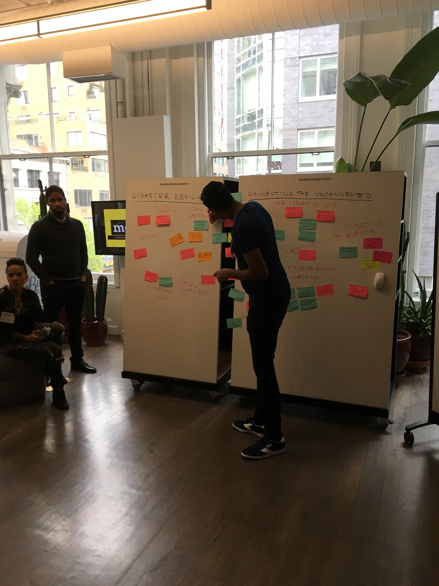

Melissa’s time-crunch version:

Moon shot

ˈmo͞on ˌSHät/

*noun*

plural noun: moonshots

1. *The launching of a spacecraft to the moon.*
2. *Planning, building, running and surviving the perfect repository environment?*

Other definitions:

*Radical solutions for complex problems, using novel, out of the box, creative thinking, making use of existing technology, game changing approaches or never thought before strategies.*

## **Moonshots Hack-a-doc IslandoraCon 2017**

## **Before the Hack/Doc:**

Think about your best idea for making Islandora better: removing a barrier in your workflow, adding a new feature, improving an existing tool to make it do more, integrating Islandora with some other software that improves them both. Think about unresolved, never before addressed needs or simply things you feel could be done better in any aspect of repositories, Islandora, preservation, metadata or any tangentially related technologies including workflows, human and community aspects, or even higher hopes that escape the traditional software talk.

Think about your local needs and problems, how you imagine working with these topics in an ever-changing and evolving world, where linked data, common languages, and collaboration are playing more and more and fundamental role.

Don’t worry about resources or barriers to getting it done. These are ‘moonshots.’ Moonshots are not something for which you need to have the how and when in your head. Moonshots can be even things that can’t be solved, but do need to live to the idea of making the digital preservation community a better place. Dream big.

## **At the Hack/Doc**

Once project groups have formed, lead facilitators will hand out sticky notes and pens. Write up your ideas on Sticky notes, one idea per Sticky. This should take 5 minutes. There is no hard limit on how many ideas per person you can come with, and if you have no ideas you want to share, that’s cool too. You can write Moonshots as individuals or as a group.

Once the writing is done, everyone groups around a whiteboard and is asked to stick their moonshot note to the right side of the whiteboard. Once everybody is done with that, the lead facilitator will read each moonshot out loud and asking the author of the idea to explain it in 30 seconds. It is very important that everyone, even if the idea is not original, not new, etc, is treated with respect. Then the entire group will try to bring that idea into CLAW context (if possible) and the note gets passed back to the left side of the whiteboard to be grouped into common themes. For example: perhaps usability, workflows, ingest could be grouped under “UX”. The idea behind this is to help people find other peers that have similar problems, needs and hopes.